**Technical Design Document**

Escapism

**Engine/3rd Party Libraries**

Escapism is being developed in Unity 2017.3.0f3 with the SteamVR Plugin obtained from the asset store and the VRTK Plugin obtained from its Github Repository.

**Platform**

Escapism is available to play on Windows 7 or higher with a HTC Vive Setup.

**System Requirements**

<https://www.vive.com/au/support/vive/category_howto/what-are-the-system-requirements.html>

**Game Development**

Unity is the game engine being used to develop the game, with code written using the C# Programming language. To enable multiple people to work on the project at different locations we are using a Github Repository to manage the project.

**Gameplay**

Escapism, being a VR game, is played from a first-person perspective. The camera moves automatically with your head and body in real life, and can be moved to areas further away with an in-game teleporter.

**UML Diagram**

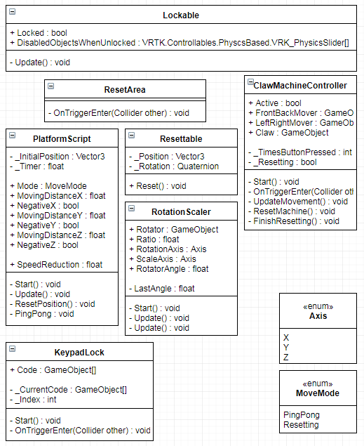

**Art Technical Requirements**

3D Models used within the game are of the FBX format.